Fire and Smoke detection Using Open-cv

IT244 Software group project -1

# ABSTRACT

This project will give the overview what is open cv and image processing what its is used for and , this project is able to detect the fire and smoke and by using this project we can reduce the number of death occur in fire incidents .

# INTRODUCTION

This project is made by using opencv in python . Opencv is a huge open-source library for computer vision , machine learning , and image processing .OpenCV is capable of image analysis and processing . this projects helps to detect fire and smoke from stereoscopic camera and after detect fire in this project I have a made a simple standalone application which used laptop web cam to detect fire and smoke then rang the alarm .

# Literature Survey

During the development of this project , some useful technical definition have been reviewed

Those are very closely connected with the fire and smoke detection using opencv are as following :-

## Image detection

## Video detection

## Street review image

## Image editor

# Features includes in project

## resize():-

we need to resize the image as to get better color values from image . Resizing an image means changing the dimensions of it, be it width alone, height alone or both. Also, the aspect ratio of the original image could be preserved in the resized image function call resize().

syntax :- cv2.resize(source, dimension size[ x ,y],[optional] interpolation)

here,

x = scale factor along the horizontal axis.

y = scale factor along the vertical axis.

Interpolation = It helps in zooming in images. Many times we need to resize the image i.e. either shirk it or scale up to meet the size requirements.

Eg.



## Blur():-

we have to blur image in order to make image more smoother and detect color efficeiently by using function name GaussianBlur

Syntax:- GaussianBlur(src, dst, ksize, sigmaX)

This method accepts the following parameters

* src − A  object representing the source (input image) for this operation.
* dst − A  object representing the destination (output image) for this operation.
* ksize − A Size object representing the size of the kernel.
* sigmaX − A variable of the type double representing the Gaussian kernel standard deviation in X direction.

## cvtColor():-

Fire and smoke has a different color , gray scale and brightness than other household object so we in order to detect more bright color so we have to get a hsv color image from blur image . to get a hsv color image we function cv2.cvtColor().

Syntax:- cv2.cvtColor(src, code, dst, dstCn)

* src:- source image
* code:-  It is the color space conversion code.
* dst:- it is the same size ouput image as src.

dstCn:-it is the number of channel in output image.

Example:-

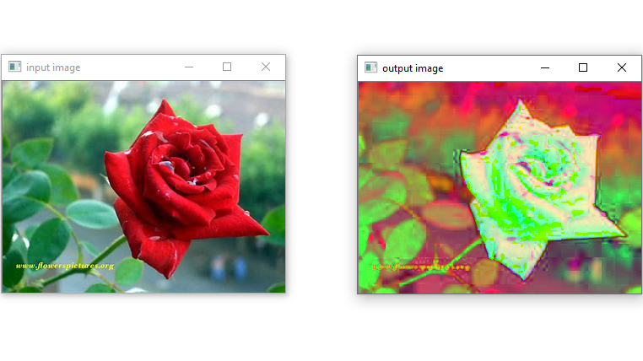

* inRange():- In order to get the pixels which has values according to our rang

we use function name inRange(). To detect fire our range of color is from lower = [18,50,50] to upper = [35,255,255] and to detect smoke our range of colors is from lower = [105,1,150] to upper = [110,50,255] by use of inRange() function we can get only pixels we need according to our range . After thresholding the pixels color values which lies between our range get the color values [255,255,255] other pixels get values to [0,0,0] .

here in example they we are detacting only red color

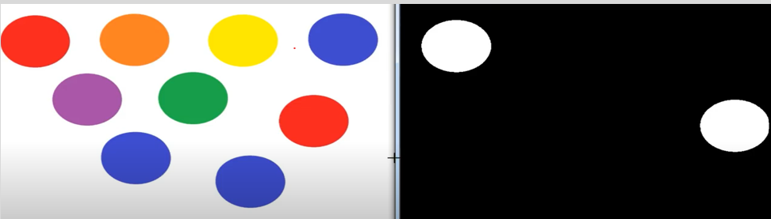

* CountNonZero :- By using this function we can get the size of all nonzero pixels if this nonzero area is big enough then fire and smoke is detected.

## Playsound :-

If the fire is detected then it plays the alarm and make alert everyone about the smoke and fire so we can save some lives.

## Reference links

<https://www.tutorialkart.com>

<https://www.tutorialspoint.com/opencv>

https://www.geeksforgeeks.org

<https://www.youtube.com/watch?v=I-RmQVM2nfc&t=3s>

<https://www.youtube.com/watch?v=JxmmOktlN6U&t=994s>

<https://www.youtube.com/watch?v=sB9DjPH6Xmg>

## Conclusion

To detect a different color is very challenging task in open cv , by using accurate range of color to detect smoke and fire we can improve detection accuracy.

